**Experiment No:- 6**

**Aim:** ASK, FSK AND PSK MODULATION TECHNIQUE

**Software required: MATLAB**

**Theory:**

MODULATION:-Modulation is a process , by which some characteristic of a carrier wave is varied in accordance with a modulating(message) signal.

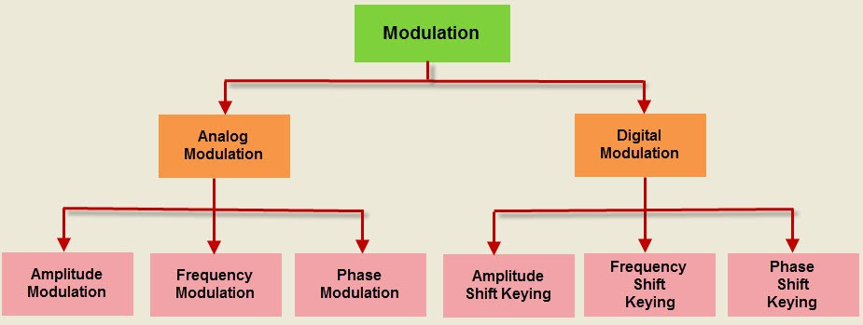

Digital modulation: It is a special kind of modulation , where the message signal is digital in nature and the carrier wave is analog(sinusoidal) in nature.

* The ASK, FSK AND PSK are analogous to AM,FM and PM respectively. The difference is that in digital modulation techniques(ASK, FAK and PSK) the modulation signal is digital in nature while in AM, FM and PM modulating signal is analog in nature.

1. **ASK (AMPLITUDE SHIFT KEYING):**

In ASK, the amplitude of the carrier wave is changed(switched) according to the digital input signal(modulating signal).

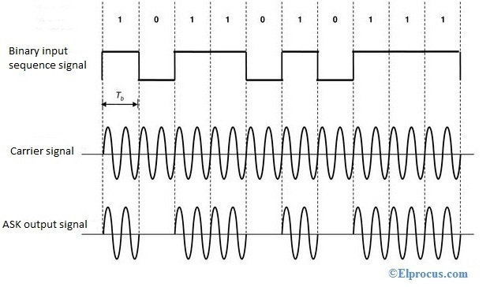

**Generation of ASK signal:**

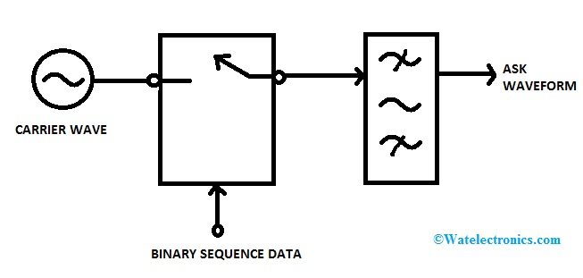

**APPLICATION OF ASK:**

1. WIRELESS BASE STATION
2. LOW FREQUENCY RF APPLICATION
3. INDUSTRIAL NETWORK DEVICES

**2. FSK(FREQUENCY SHIFT KEYING):**

If the frequency of sinusoidal carrier wave is varied (switched) depending on the digital input signal, then it is known as the frequency shift keying.

Generation of FSK:

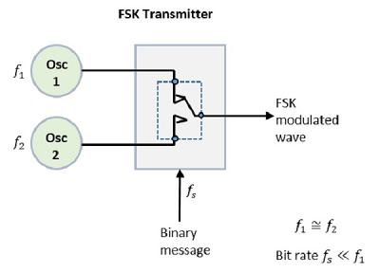

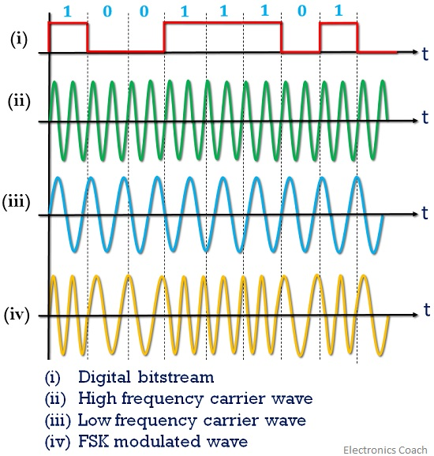

APPLICATION OF FSK:

1. High frequency radio transmission.

**3. PSK(PHASE SHIFT KEYING):**

In PSK, phase of the carrier wave(analog in nature) is switched as per the input digital signal.

Generation of PSK:

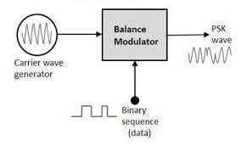

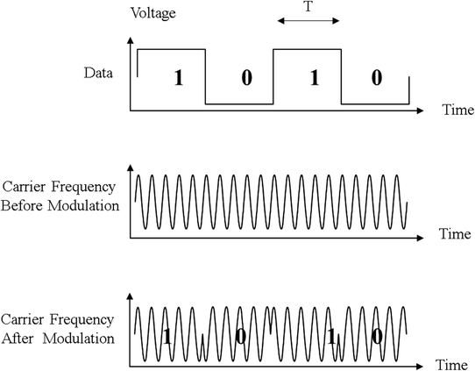

**Application of psk:**

1. **It is widely used for wireless LANs, RFID and Bluetooth communication.**